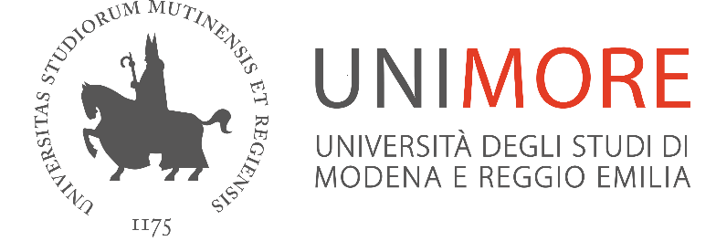

Subject: Unimore - Coronavirus 8 March
To the recipients as addressed above

Following the Prime Ministerial Decree of 8 March 2020, Unimore issues the following provisions:

Office operation
All front-office activities are suspended, both for external and internal users: help desks are closed and may only be accessed online or by phone.

Internal users are invited to call the offices or access them via the Internet.

Organisation

The administration continues to promote smart working solutions and the opportunity for employees to request leaves and accrued holidays. The facility manager shall evaluate the situation and ensure a balanced compromise between the personnel working from the office and that authorised for smart working or on holiday/leave.
Freedom of travel for workers within the province and between provinces.
EDUCATION ACTIVITIES
All types of internships, both within and outside the University are suspended, except for those expressly indicated in the Prime Ministerial Decree, that is “without prejudice to the opportunity to carry out distance training activities except for courses for doctors undergoing specialised medical training and courses of specific training in general medical practice, as well as the activities of healthcare professions trainees”, the latter ones to the discretion of the competent educational authorities.

Attendance to laboratories is suspended for the preparation of the degree thesis
The research and educational activity of PhD students that is carried out in the University premises is suspended until further provision issued by the Department’s Directors.
Degree final examinations may take place with the Board gathered via electronic means, according to the organisational means defined by the Department’s Directors and the Presidents of the degree programme.
New schedules and more detailed information will be communicated during the next days. Please read the various communications that will be published on the relevant Department websites.
LIBRARIES AND UNIVERSITY MUSEUMS
Libraries and university museums will be closed.
All the other provisions previously issued on Thursday 5 March remain valid.
In particular, only distance lessons and examinations will take place.
Lastly, attached please find the explaining sheets issued by Regione Emilia Romagna on 8 March 2020.

